APP DEVELOPMENT (FACE DETECTION AND RECOGNISION USING ANDROID STUDIO)

Flowchart describing an overview of the system framework

For face recognition, we should use an image with dimensions of at least 480x360 pixels. For ML Kit to accurately detect faces, input images must contain faces represented by sufficient pixel data. Generally, each face we want to detect in an image should be at least 100x100 pixels. If we want to detect the contours of faces, ML Kit requires higher resolution input: each face should be at least 200x200 pixels.
If we detect faces in a real-time application, you might also want to consider the overall dimensions of the input images. Smaller images can be processed faster, so to reduce latency, capture images at lower resolutions, but keep in mind the above accuracy requirements and ensure that the subject's face occupies as much of the image as possible. In this project, we can implement an android studio application with the help of Android studio using java language.

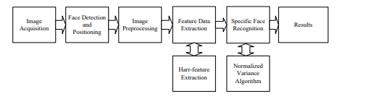

- The facial image acquisition procedure which is creates low-quality face images. This occurs because imaging situations like illumination, occlusion, or noise can change among the pictures.
- To accomplish the optical pictures, it presented an image acquisition technique for face recognition. The detection procedure is the basis for additional tasks as a face that cannot be recognized before it is contained in a picture. An image can comprise more than one face.
- This phase is accomplished by utilizing different entity detection procedures (Altunet al. 2018). The main assignment of these instances is to find the function of the face and the coordinates of the area of the face.
- The bounding is created by utilizing these details. In this framework, automated face recognition is a technique where the procedure removes meaningful facial segments. These kinds of features are valuable for variety and conducting conflicts with the database.

